C:\Program Files (x86)\Microsoft Office\MEDIA\OFFICE12\Lines\BD21313_.gif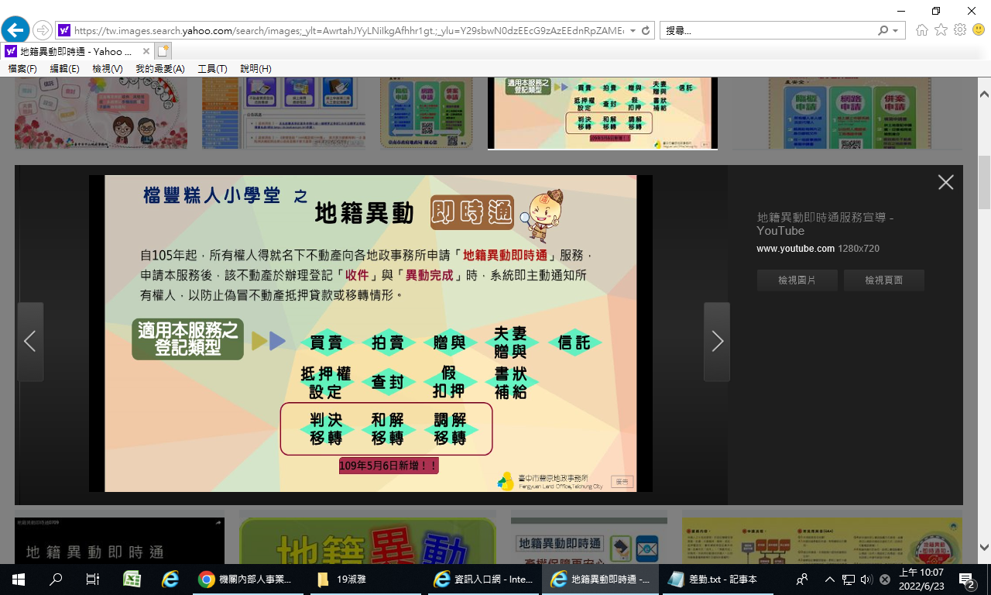

斗南地政關心您